Week Ending: | DAY: |  |  | Subject: Creative Arts
Duration: 60mins per lesson |  |  |  | Strand: Appreciating and Appraising
Class: B2 | Class Size: |  |  | Sub Strand: Visual Arts & Performing Arts
Content Standard:  Demonstrate understanding of how to generate own ideas for artistic expressions on the people. |  |  | Indicator:  B2.1.4.6. /B2.2.4.7. report own views and feelings about the displayed artworks and suggest how the artworks can be modified or improved |  |  | Lesson:  1 OF 1
Performance Indicator:  Learners can report own views and feelings about the displayed artworks and suggest how the artworks can be modified or improved |  |  |  |  | Core Competencies:  Decision Making and Creativity
Teaching/ Learning Resources |  | Photos, videos, art paper, colors and traditional art tools
References: Creative Arts Curriculum Pg. 36
DAY | PHASE 1: STARTER | PHASE 2: MAIN | PHASE 3: PLENARY
 | Engage learners to play games and sing songs to begin the lesson.  Review learners understanding in the previous lesson using questions and answers | Let learners use their senses to appreciate and appraise their own artworks.  Make decisions on agreed guidelines to appreciate and appraise an artwork. E.g. clay pot  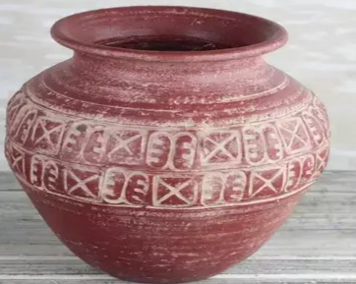  Theme: Unity  Subject matter: Historical  Media: Clay  Techniques: coiling method  Uses: for fetching and storing water  Future modification: addition of handles | Assessment: Present learners with different artworks for them to use the guidelines in appreciating and appraising.  Summarize lesson activities with learners.
 | Engage learners to play games and sing songs to begin the lesson.  Review learners understanding in the previous lesson using questions and answers | Performing artworks include dance, music and drama.  Let learners use their senses to appreciate and appraise their own artworks.  Make decisions on agreed guidelines to appreciate and appraise an artwork. E.g. Agbadza dance  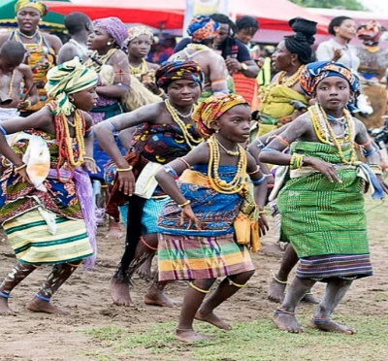  Let learners talk about the theme, gestures, makeup, costume, stage use and stage setting as they watch the video or pictures of the dance. | Review the lesson activities through questions and answers.

